**Слемнёв Виктор Николаевич**

**Вариант 12**

Регулярное выражение:

proc(□)+ (start(cos(y*)+sin(x+ )))* □ + end

Введем свои обозначения:

a-proc

b-□

c-start

d-cos

e-y

f-sin

g-x

h-end

**Регулярное выражение: a(b)+(c(d(e*)+f(g+)))*b+h**

1. Abcdebh
2. Abbcdeebbh
3. Abcfggbh
4. Abbbh
5. Abbbbbh
6. Abcfgbh
7. Abbbbbh

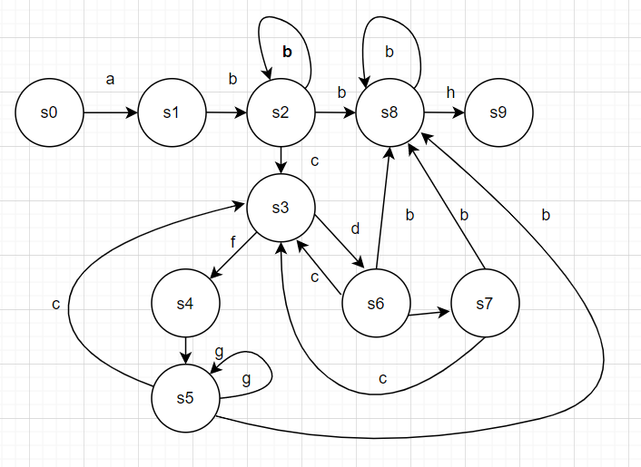 **a(b)+(c(d(e*)+f(g+)))*b+h**

|  |  |  |  |  |  |  |  |  |
| --- | --- | --- | --- | --- | --- | --- | --- | --- |
|  | a | b | c | d | e | f | g | H |
| S0 | {S1} |  |  |  |  |  |  |  |
| S1 |  | {S2} |  |  |  |  |  |  |
| S2 |  | {S2}{S8} | {S3} |  |  |  |  |  |
| S3 |  |  |  | {S6} |  | {S4} |  |  |
| S4 |  |  |  |  |  |  | {S5} |  |
| S5 |  | {S8} | {S3} |  |  |  | {S5} |  |
| S6 |  | {S8} | {S3} |  | {S7} |  |  |  |
| S7 |  | {S8} | {S3} |  |  |  |  |  |
| S8 |  | {S8} |  |  |  |  |  | {S9} |
|  |  |  |  |  |  |  |  |  |

1. Abbbh